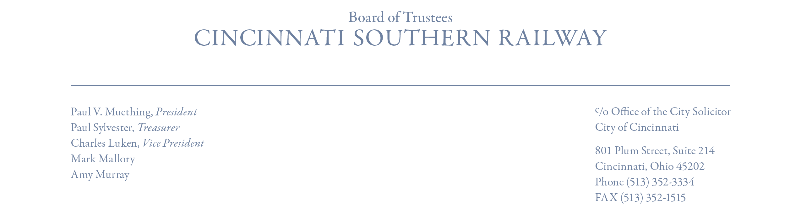
Statement
Paul V. Muething, Chair
Cincinnati Southern Railway Board of Trustees
Cincinnati Southern Railway Sale Closes
CINCINNATI, OH – March 15, 2024: On behalf of the Board of Trustees of the Cincinnati Southern Railway, I am proud to announce the closing of the sale of all assets of the railway to Norfolk Southern Railway Company, an affiliate of Norfolk Southern Corporation (NYSE: NSC). At a special meeting of the CSR Board held on January 8, 2024, after comprehensive review, the Board authorized me on its behalf to execute all documents required for the sale closing. I have done that. We received today from Norfolk Southern $1.6 billion in sale proceeds and an additional $20 million in deferred transaction fees.
At the CSR Board’s special February 29, 2024 meeting, the Board voted unanimously to approve a contract with UBS Financial Services to serve as its financial advisor as required by Ohio law. In addition, the Board approved an Investment Policy Statement, as required by Ohio law, indicating how it would invest the sale proceeds to achieve a goal of an average annual return of at least 5.5%, which is projected to generate approximately $55 million annually for the City of Cincinnati, more than double current lease payments generated annually in the past by the railway. Also as required by Ohio law, these funds can be used by the City of Cincinnati only to “rehabilitate, modernize, or replace existing infrastructure” and can never be used for the construction of new infrastructure improvements.
As we said on November 21, 2022, when we proposed the sale of the railway, and before it was approved by the voters of Cincinnati, “This transaction gives us the ability to deliver transformative and perpetual value to the City and its citizens.” That is precisely what is now occurring.
We want to thank the citizens of Cincinnati for their vote in support of the sale on November 7, 2023. Special thanks to my colleagues on the CSR Board of Trustees: Charlie Luken and Mark Mallory (former Cincinnati mayors), Amy Murray (a former Cincinnati City Council member) and Paul Sylvester (a 40-year board member). We also thank Mike DeWine (Governor of Ohio) and the Ohio Legislature, especially those legislators from Southwest Ohio, for amending Ohio law to enable the establishment of a trust fund from sale proceeds which will generate substantial annual earnings for the benefit of the citizens of Cincinnati. In addition, we offer our special thanks to the Mayor of Cincinnati, Aftab Pureval, and the members of Cincinnati City Council for their support through this process.
# # #

